**Hugh - 1 917 952 9100**

**“Awareia” MVP Development Handoff Document**

**1. Overview of “Awareia”**

Awareia is an **AI-powered youth soccer scouting and analytics platform** designed to help coaches **analyze opponents, plan smarter, and win more**. The MVP will focus on **crowdsourced scouting insights**, **league match data**, and **AI-driven opponent reports**.

**2. Core Features for MVP (Phase 1)**

**A. User Registration & Team Association**

* Coaches sign up and **link their team** to their league (EDP or WYSL).
* Access **historical match data** for their team and opponents.

**B. Opponent Scouting Reports (Coach Input + AI)**

* Coaches can **submit scouting reports** on teams they have played.
* AI will assist with **structured prompts** if input is rough or incomplete.
* Coaches can also **speak** their assessment, and AI will transcribe and structure the data.

**C. AI-Powered Opponent Insights**

* Awareia aggregates coach submissions and provides **summarized insights** on opponents.
* AI-generated reports include:
  + **Opponent’s strengths & weaknesses**
  + **Goal-scoring trends** (e.g., strong early-game offense, weak on set pieces)
  + **Defensive vulnerabilities**
  + **Common formations and tactics**

**D. League Match Data Integration**

* Display **past match history, rankings, goals scored/conceded**.
* Pull data from **EDP & WYSL match tables**.
* AI-enhanced insights on **opponent’s seasonal performance**.

**E. SWOT Analysis for Own Team**

* AI will **compile a strengths, weaknesses, opportunities, and threats (SWOT) analysis** for the user's team.
* Opponent feedback will contribute to the SWOT assessment, allowing teams to **see how rivals perceive them**.
* AI-generated insights will identify **recurring trends** in team strengths and weaknesses.
* Coaches will be able to compare **performance trends relative to opponents over time** to adjust strategy effectively.

**F. Match Reports & Notifications**

* Coaches receive **AI-generated opponent reports** ahead of their matches.
* Weekly match **push notifications** with upcoming opponent insights.
* Personal dashboard to track **past opponents and reports**.
* SWOT insights will also be included in **pre-match and post-match reports**.

**G. Subscription-Based Monetization Model**

* Free tier with **basic access to historical match data and limited AI insights**.
* Paid subscription tiers unlocking:
  + **Deeper opponent scouting reports** with AI-driven tactical breakdowns.
  + **Personalized SWOT insights for team and player-specific analysis**.
  + **Premium pre-match preparation tools** such as set-piece analysis and trend detection.
* Coaches and clubs can **subscribe monthly or annually**.
* Potential for **league-wide partnerships** offering bulk pricing for organizations.

**3. User Flow & Experience**

1️⃣ **Coach Registration** → Connect to their team → Gain access to **past match data & scouting reports**. 2️⃣ **Submit Opponent Assessment** → AI assists with structured inputs → Data stored for future matchups. 3️⃣ **Receive Pre-Match Reports** → AI delivers **opponent scouting summaries** → Coaches can refine strategies. 4️⃣ **Match Insights Dashboard** → Coaches can review **all past opponent reports** in one place. 5️⃣ **SWOT Analysis Dashboard** → Coaches see **how opponents view their team** and adjust accordingly. 6️⃣ **Subscription Plan Selection** → Free and premium users access different tiers of insights.

**User Flow Diagram:** Matchyn User Flow

**4. Data Structure & Sources**

* **League Data Sources:** EDP & WYSL match tables, standings, goal differentials, historical records.
* **Coach-Submitted Data:** Text-based scouting reports, voice-to-text analysis.
* **AI Processing:** Summarization & trend identification based on coach insights + match data.

**5. Tech Stack Recommendations**

**Frontend:**

* **React.js** (or Vue.js) for a fast, modern UI.
* **TailwindCSS** for a sleek, responsive design.

**Backend:**

* **Node.js + Express** (or Python FastAPI) for handling API requests.
* **PostgreSQL** or **MongoDB** for storing match data & scouting reports.

**AI & NLP Integration:**

* **OpenAI GPT-4 API** for **scouting report summarization & prompt completion**.
* **Whisper AI** for **voice-to-text transcription** of coach insights.

**6. API & AI Integration Plan**

* **Data Aggregation:** Scrape/pull match data from **EDP & WYSL** sources.
* **AI Summarization:** Convert **raw scouting data into structured, readable reports**.
* **Push Reports:** Automate **match insights delivery** before game days.
* **Voice Input Processing:** Enable coaches to **speak their assessments** for easier data entry.
* **SWOT Analysis Generation:** AI compiles **team strengths & weaknesses**, factoring in **opponent assessments** and **performance data**.

**7. Nice-to-Have Features (Future Enhancements)**

✔ **Opponent Form Guide & Season Tracker**

* AI tracks opponent **momentum & form** (e.g., last 5 matches W-D-L-L-W).
* Predicts **how an opponent might approach the next game** based on trends.
* Useful for understanding **recent tactical shifts & lineup changes**.

✔ **Drill & Training Recommendations Based on Team SWOT**

* AI suggests **training drills to address weaknesses** (e.g., defensive lapses, set-piece defending).
* Aligns **practice sessions with actual game data insights**.
* Coaches can **customize drills** based on opponent trends & team needs.

✔ **Crowdsourced Opponent Scouting Score**

* Opponents get an **aggregated AI-generated rating** based on multiple coach reports.
* Coaches can **see consistency in reports vs. one-off impressions**.
* Creates a **robust scouting database** for youth soccer clubs.

**8. Future Roadmap**

🚀 **Phase 2 (Post-MVP Enhancements)**

* Expand SWOT analysis to **player-specific insights**.
* Introduce **live match AI assistant** for real-time tactical feedback.
* Implement **set-piece analysis and AI-generated strategy recommendations**.

📊 **Phase 3 (Advanced AI & Integration)**

* Integrate with **Hudl, Veo, or other video analysis platforms**.
* Offer **AI-based game simulations and predictive analytics**.
* Develop **custom AI training modules based on match data trends**.

🏆 **Phase 4 (Scalability & Commercial Expansion)**

* Expand to **additional youth soccer leagues beyond EDP & WYSL**.
* Launch **mobile-friendly version for quick insights on the go**.
* Optimize and scale **subscription-based monetization models**.

**9. Next Steps for Development Team**

✔ **Build User Registration & Team Association** ✔ **Develop Opponent Scouting Input System** (text + voice-enabled) ✔ **Integrate League Match Data Sources** (EDP & WYSL API/scraping setup) ✔ **AI Summarization for Reports** (using GPT-4) ✔ **Design Coach Dashboard & Match Reports Delivery** ✔ **Develop SWOT Analysis Feature for Team Performance Insights** ✔ **Test MVP with Early Adopters (Beta Launch)**

Data source:

EDP : <https://newyorkclubsoccer.com/nycsl/>

[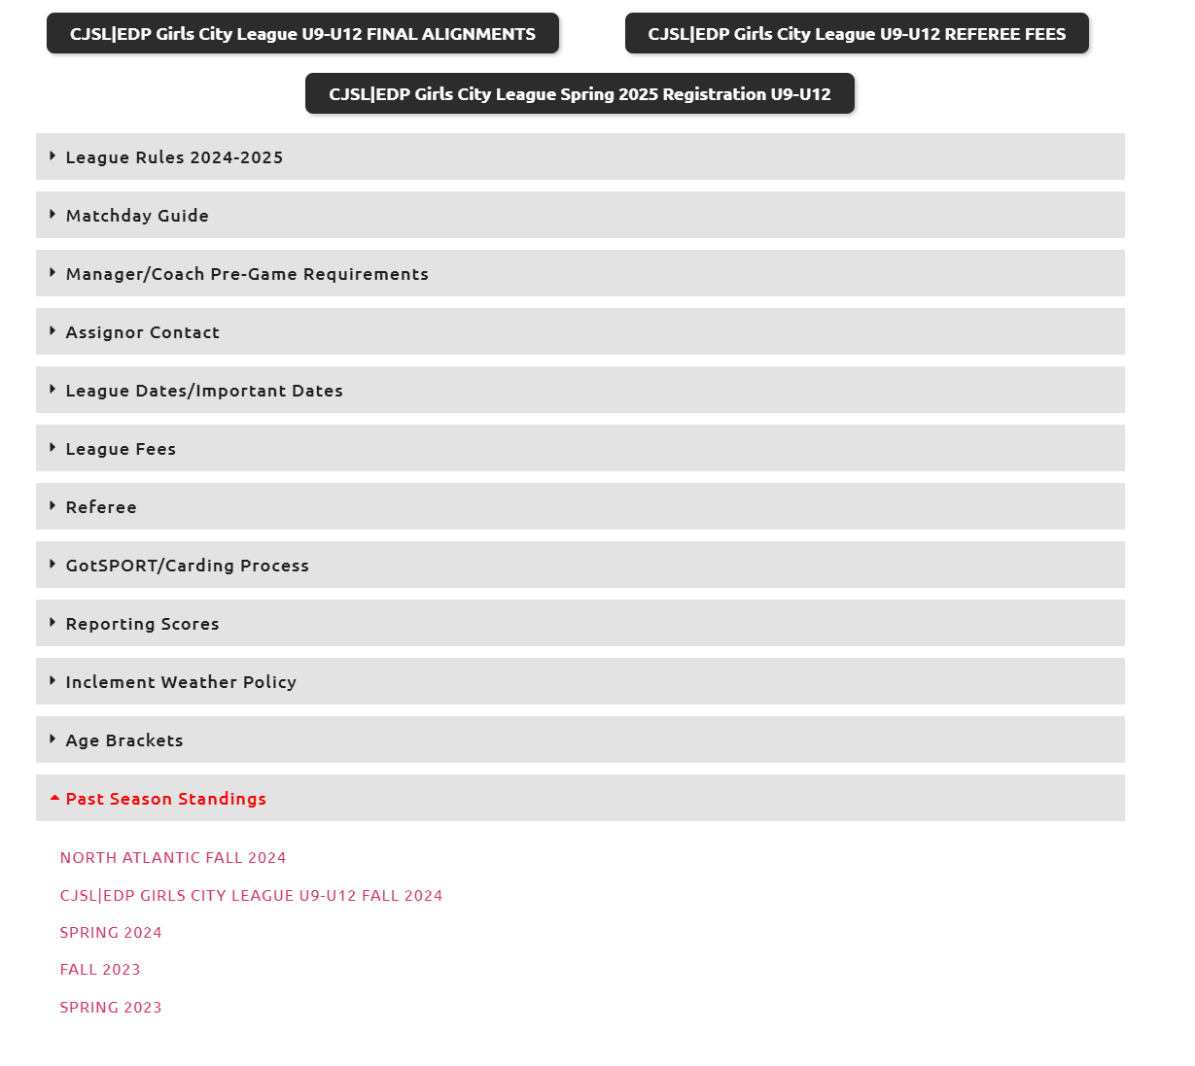](https://newyorkclubsoccer.com/nycsl/)

WYSL: <https://system.gotsport.com/org_event/events/34449/clubs>

Some sample AI Assessment:

What We Know About Lansdowne (Fall 2024 Performance)

They Can Score – A Lot  
65 goals in 21 games (avg 3.1 goals per match).  
They put up big numbers against weaker teams, so they know how to take advantage when given space.  
Defense? Not Perfect  
They conceded 26 goals in 21 games (about 1.24 per match).  
When put under pressure, they’ve given up goals in key moments.  
Mixed Consistency  
Finished with 11 wins, 5 draws, and 5 losses → hot and cold performances.  
Had dominant wins (4-1 over Manhattan Celtic FC) but also dropped points against teams with solid defenses.  
Takeaways from Our Last Matchup (Oct 5, 2024 – 2-2 Draw)

We can match them—they don’t have some untouchable edge over us.  
We need better control in key moments—they capitalize on loose defending and space in transition.  
They aren’t unbeatable, but if we let them dictate play, we’ll be on the back foot.  
Game Plan for Beating Lansdowne

1. Make Them Uncomfortable – High Press & Quick Play

They’re used to controlling games. Let’s not let them settle.  
Press their back line early—force them to make mistakes in their own half.  
Win the ball higher up the field and immediately look for through balls & quick shots.  
Coaching Note: First 10-15 minutes are huge—set the tone early.  
2. Stay Tight in Defense – No Easy Goals

Man-mark their key attacking players—don’t give them time to turn.  
Keep our defensive shape compact—force them wide instead of letting them slice through the middle.  
If they start pushing numbers forward, we stay disciplined and look to hit them on the break.  
Coaching Note: They score a lot, but they struggle when teams don’t give them space.

3. Own the Midfield – Control the Tempo

Don’t let them dictate play—we need midfielders to win second balls and keep possession.  
If we control the middle, they’ll get frustrated and lose their rhythm.  
Play quick passing sequences to move their defenders out of position.  
Coaching Note: If we slow the game down at the right times, they won’t get their usual attacking flow.

4. Win the Set-Piece Battle

Defensively, be disciplined on corners & free kicks—they look for cheap goals here.  
On offense, attack the back post—they’ve struggled marking late runs into the box.  
Coaching Note: First contact is everything—be aggressive, and we win these moments.

Final Message for the Team

We match up well with these guys—we’ve done it before.  
Take advantage of their defensive gaps by being aggressive early.  
Don’t let them dictate the pace—if we control the midfield, we control the game

Note this site as well - They also seem to aggregate data from Got Sports. I like how they set up their tables. [DO NOT USE THIS SITE AS A SOURCE OF DATA]

<https://youthsoccergames.com/#gsc.tab=0>

